Online Retail Sales Analysis Using Power BI

1. Project Objective
The objective of this project is to analyze online retail sales data using Power BI to identify revenue trends, top revenue-generating items, customer purchasing patterns, and country-wise sales performance. The project involves cleaning and validating transaction data, developing an interactive dashboard, and deriving actionable business insights to support data-driven decision-making.

2. Dataset Overview
The project uses an online retail transactional dataset containing sales records from December 2010 to December 2011.
The dataset includes the following key attributes:
- InvoiceNo: Unique invoice identifier for each transaction.
- StockCode: Product or item identifier.
- Description: Name or description of the item.
- Quantity: Number of units purchased.
- InvoiceDate: Date and time of the transaction.
- UnitPrice: Price per unit.
- CustomerID: Identifier of the customer.
- Country: Country associated with the transaction.
The dataset was analyzed to understand sales performance across different months, products or items, customers, and countries.

3. Data Cleaning and Preparation
The dataset was prepared for analysis using Power Query in Power BI. The following steps were performed:
- Filtered the data to include only records marked as valid sales using the Valid_Sale column.
- Excluded cancelled transactions identified by invoice numbers beginning with the letter C.
- Excluded transactions with non-positive quantities or unit prices according to the validation rules.
- Used the prepared dataset to create measures for total revenue, total orders, total customers, total units sold, and average order value.
- Created a month-year field from the invoice date to support chronological monthly revenue analysis.
These preparation steps helped ensure that the dashboard focused on valid sales transactions.

4. Key Performance Indicators (KPIs)
The following KPIs were calculated to evaluate the overall sales performance of the online retail business.
KPI | Value
Total Revenue | £10,666,669.24
Total Orders | 19,960
Total Customers | 4,339
Total Units Sold | 5,588,370
Average Order Value | £534.40

KPI Interpretation:
- Total Revenue: Represents the total revenue generated from valid sales transactions.
- Total Orders: Indicates the number of distinct valid invoices.
- Total Customers: Represents the distinct customer IDs recorded in the filtered dataset.
- Total Units Sold: Measures the total quantity of items sold.
- Average Order Value: Represents the average revenue generated per order, calculated by dividing total revenue by total orders.

Dashboard Visualization
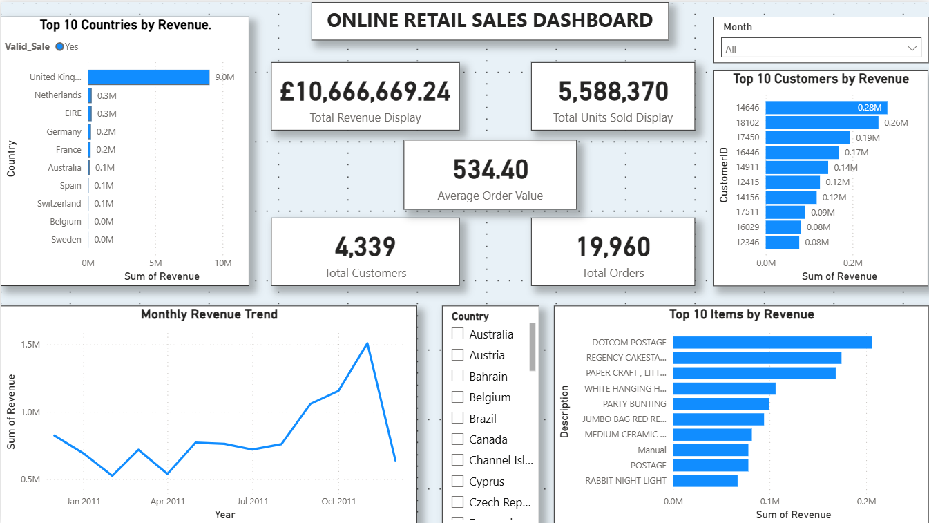
5. Key Findings and Business Insights
5.1 Country-wise Revenue Performance
The United Kingdom generated approximately £9.03 million in revenue, accounting for around 84.6% of total revenue. The Netherlands ranked second, with revenue of £285,446.34. This indicates that revenue was heavily concentrated in the UK market.
5.2 Monthly Revenue Trend
November 2011 recorded revenue of £1,509,496.33, making it the highest-revenue month identified in the dashboard. This suggests a significant increase in sales toward the end of the year.
5.3 Item-wise Revenue Performance
DOTCOM POSTAGE generated £206,248.77 in recorded revenue. Since this represents a postage-related charge rather than a conventional physical product, it is useful to distinguish such items when interpreting product performance.
5.4 Overall Sales Performance
The business generated total revenue of £10,666,669.24 from 19,960 valid orders, with 5,588,370 units sold. The average order value was £534.40, providing a useful measure of revenue generated per order.
6. Business Recommendations
- Diversify geographic markets: Explore opportunities to increase sales in countries outside the UK to reduce dependence on a single market.
- Investigate seasonal sales patterns: Analyze the products and customer purchasing behaviour that contributed to the November 2011 revenue peak.
- Improve item-level reporting: Distinguish merchandise from postage charges and other non-merchandise entries when evaluating product performance.
- Monitor key sales KPIs: Track revenue, order volume, customer count, units sold, and average order value regularly to identify changes in business performance.
- Use interactive filtering: Leverage the dashboard's month and country slicers to compare performance across different periods and markets.

7. Tools and Technologies Used
- Microsoft Power BI Desktop: Used to create an interactive sales dashboard and visualize business performance.
- Power Query: Used to filter and prepare the dataset for analysis.
- DAX (Data Analysis Expressions): Used to calculate KPIs such as total revenue, total orders, total customers, total units sold, and average order value.
- Data Visualization: Used to represent monthly revenue trends, country-wise revenue, and top revenue-generating items and customers.

8. Project Limitations
- The dataset covers transactions from December 2010 to December 2011, limiting the analysis to this period.
- The dataset does not contain product cost information; therefore, profitability cannot be calculated.
- Product category information is not explicitly available, limiting category-level analysis.
- Revenue concentration indicates where sales occurred but does not independently explain the reasons behind customer or market behaviour.
- The analysis depends on the accuracy and completeness of the available transaction records.
9. Conclusion
This project demonstrates how data preparation, DAX calculations, and interactive visualizations can be used to analyze online retail sales performance. The Power BI dashboard provides insights into revenue trends, country-wise sales distribution, customer contributions, and item-level revenue.
The analysis identified the United Kingdom as the dominant revenue-generating market and November 2011 as the highest-revenue month identified in the dashboard. The findings and recommendations can support further investigation into market diversification, seasonal sales patterns, and item-level performance.
Overall, the project strengthened practical skills in data cleaning, KPI development, data visualization, and business insight generation using Power BI.

